**Weather Web Application Using**

**HTML,CSS,JS,Ajax**

**Client Side Technologies**

**Assignment-1**

**BE in Software Engineering**

**(4th year) Level-8**

**Submitted By:- Varun Kumar Tiwari**

**Student Id- A00268806**

**Athlone Institute Of Technology**

**Ireland**

November 14, 2019

**Detailed Report On Weather Web Application**

**Title of the Project:-** Weather Application

**Introduction:-**

Weather Application is a website which can be used to check the weather forecast. This website is developed by web technologies such as HTTP, CSS, JavaScript, AJAX, PHP and forgetting the real-time data an open Weather API is used. Third-party libraries Chart.JS is also been used to display a dynamic chart that helps to enhance the user experience.

Weather Application takes city name as an input and shows 5 days prediction and also 3 hours prediction of the current day. Two graphs display the variation between temperature and wind.

**Requirement:-**

* **API:-** The API used in this website is taken from OpenWeatherMap which provides the 5 days and 3-hourly forecast for each day based on the city user have searched. In this API there were multiple information but the information used by the website are dates, temperatures, winds, clouds, humidity and Icons.
* **Ajax and XML:-** This web application will use AJAX (Asynchronous JavaScript + XML) for asynchronous data retrieval using XMLHttpRequest (XHR) objects as described in Labs in order to connect to the Weather Map APIs and retrieve data. Data will be returned in XML which is a lightweight data interchange format.
* **Chart.js:-** Website used Chart.Js which is an open-source library that helps easily to visualize the data using Javascript in a graphical format.

**Functionality Used:-**

* HTML
* CSS
* Javascript
* Ajax
* XML
* Chart.JS

**Screenshot:-**

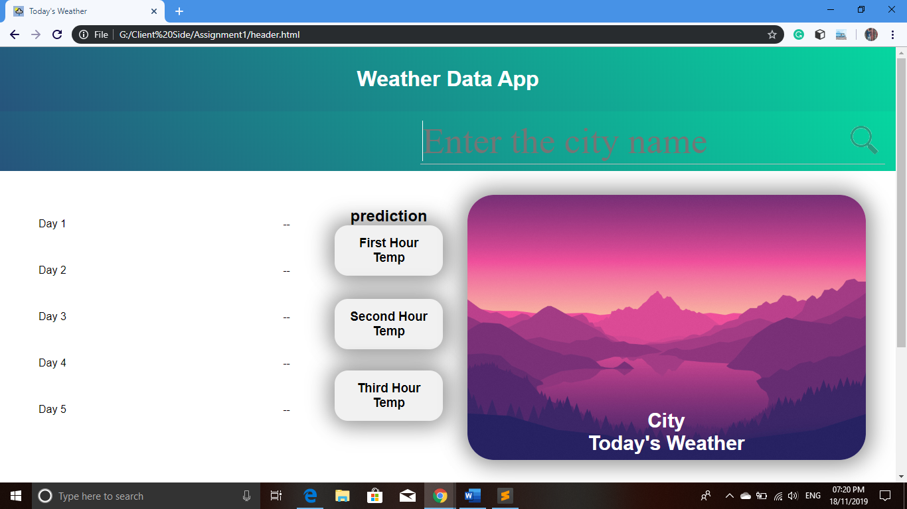

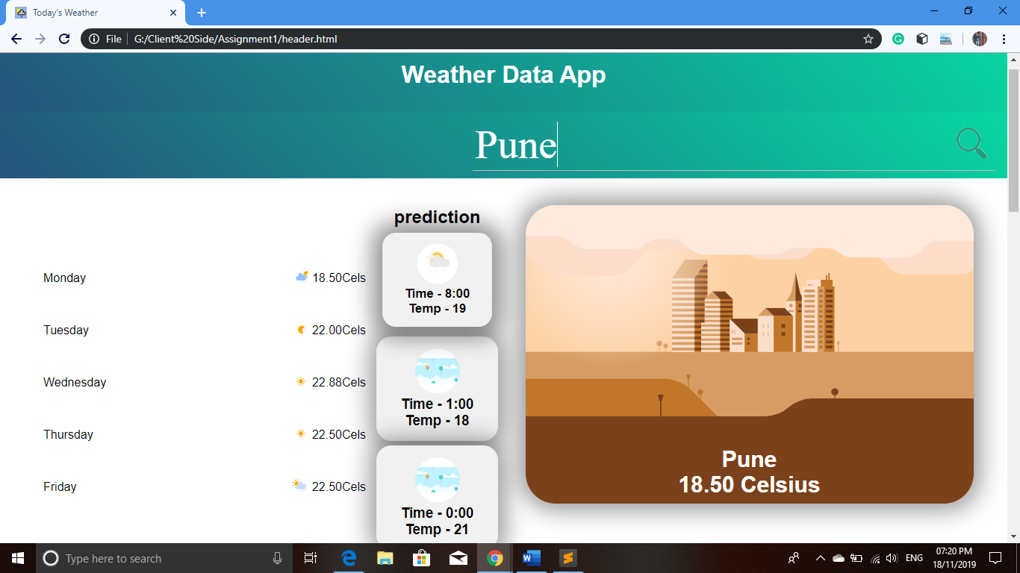

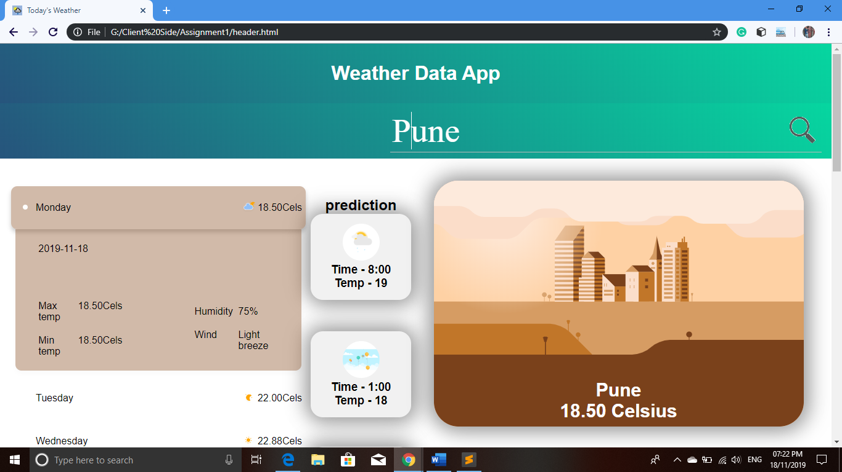

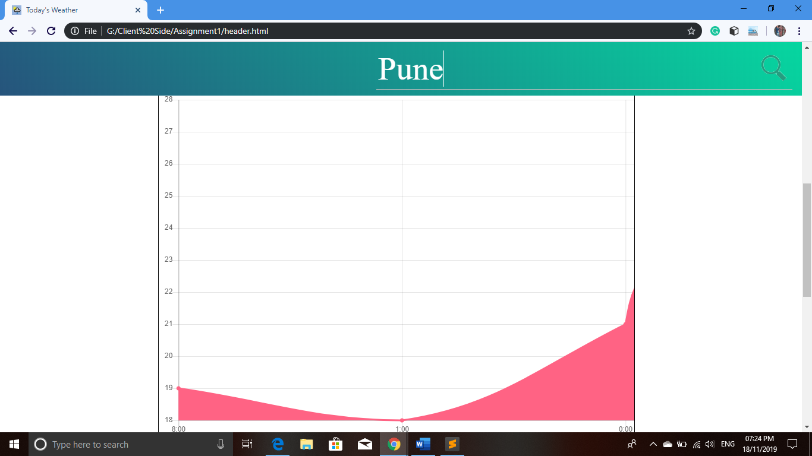

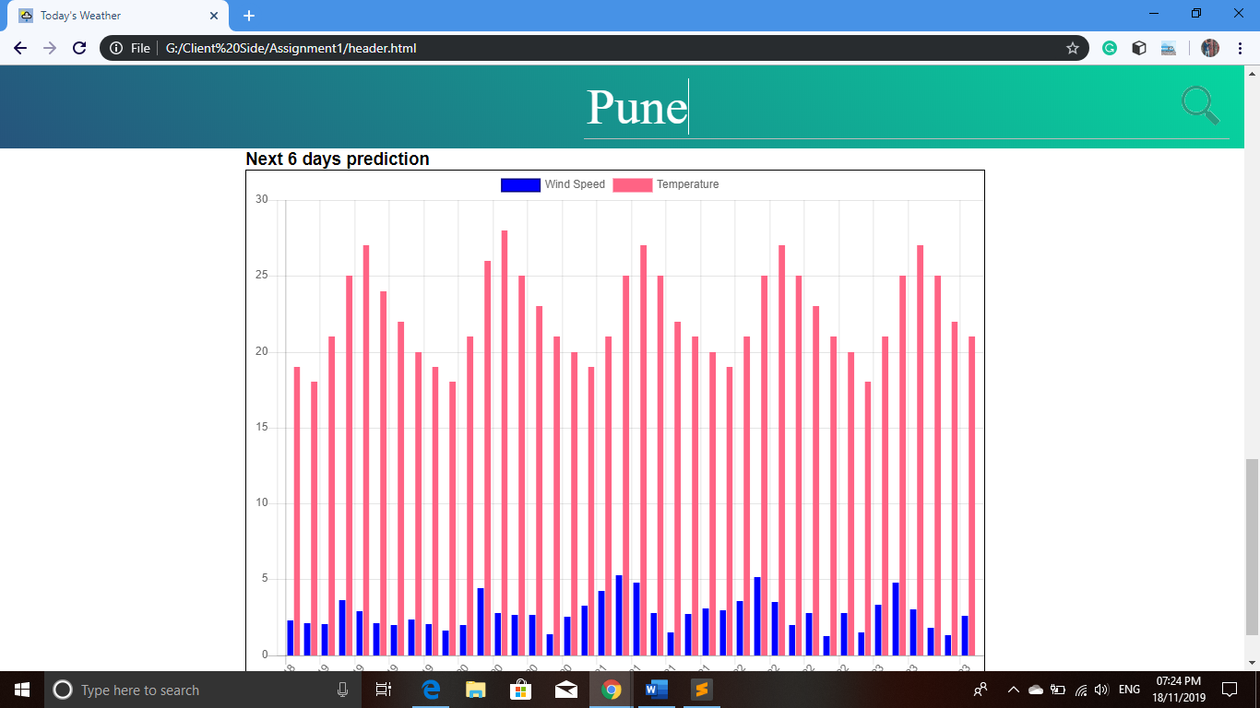

**Description Of Work:-**

This webpage allows users to search for weather forecast information using the OpenWeatherMap API and Chart.Js and display the results.

* A user will first open a page in which he/she can enter City name to check weather forecast.
* Once the user has provided data and hits “Enter” button. The webpage must use JavaScript to make the requests to the API, receive and extract data from the received XML and display the results.
* The result includes 5 days name and current temperature with weather icon it will be displayed in a list. After clicking on any day name another list will appear which will show more details of that day. Some cards are also showing data relevant to current day.
* It will also display the 3 hours and 5 day forecast in a chart by time and date respectively.

**Conclusion:-**

This application has been computed successfully. It is user friendly and has required various options which can be utilized by the user to perform the desired operations.

The goals that are achieved by the software are :-

* Optimum utilization of resources
* Efficient management of records
* User Friendly
* Less processing time and getting required information and data
* Portable and flexible for further enhancement.